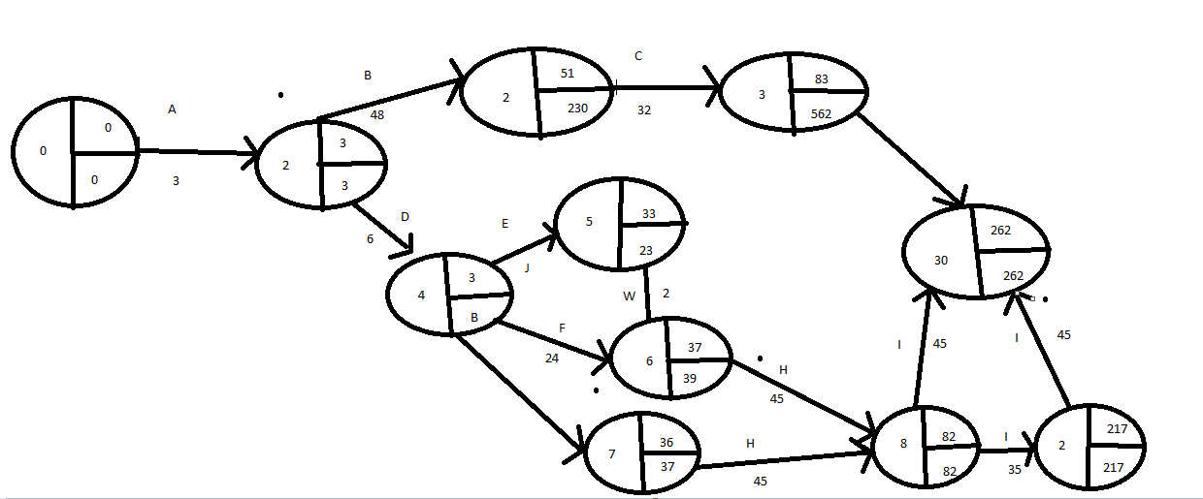

|  |  |  |
| --- | --- | --- |
| ACTITUD | DREDESORA | DURACION |
| A | - | 3 |
| B | A | 48 |
| C | B | 32 |
| D | A | 5 |
| E | D | 5 |
| F | DF | 29 |
| G | D | 8 |
| H | FG | 95 |
| I | H | 33 |
| J | HI | 43 |